***Concentration Enhancement For A 60 Year Old***

1. **Mindfulness Meditation:**

Encourage regular mindfulness meditation sessions to improve focus and attention.

Suggest starting with short sessions and gradually increasing the duration as concentration improves.

[**https://youtu.be/ZToicYcHIOU?si=U9RSKI3TPkN--K73**](https://youtu.be/ZToicYcHIOU?si=U9RSKI3TPkN--K73)

**10 minutes meditation**

[**https://youtu.be/ssss7V1_eyA?si=EfHgGf3cH8miVY7I**](https://youtu.be/ssss7V1_eyA?si=EfHgGf3cH8miVY7I)

**5 minutes mindfulness meditation**

1. **Deep Breathing Exercises:**

Teach deep breathing techniques to help calm the mind and increase oxygen flow to the brain.

Practice deep breathing exercises as a daily routine, especially before engaging in mentally demanding tasks.

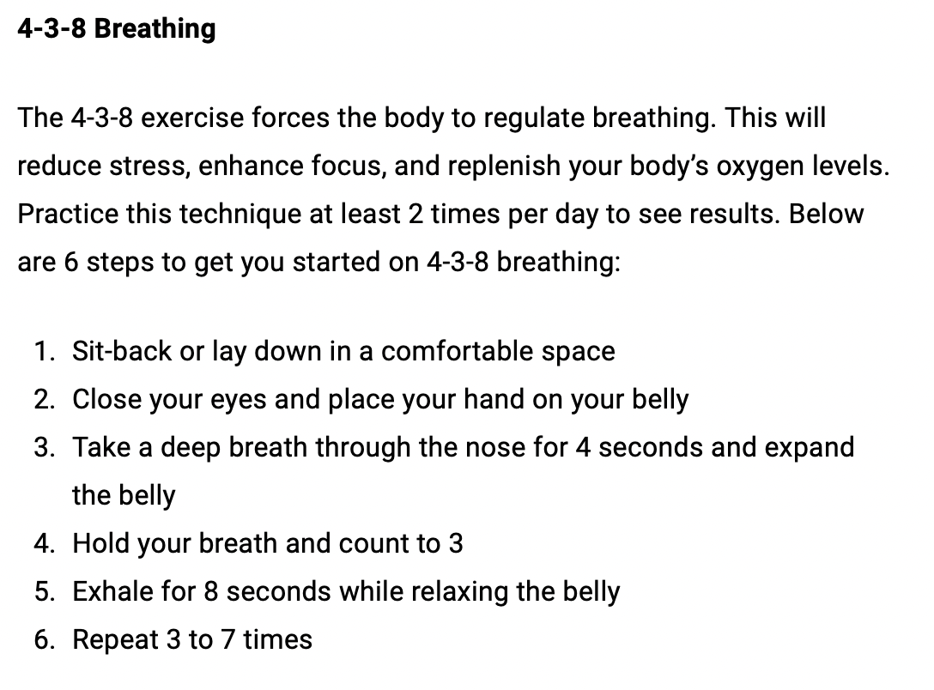

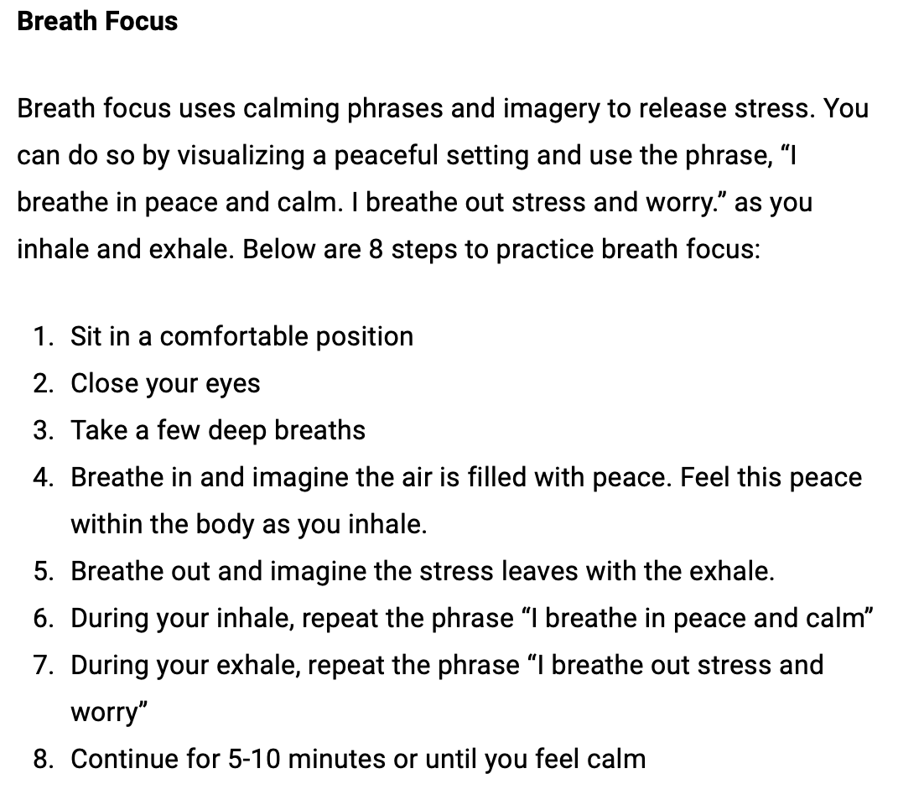

1. **Cognitive Training Games:**

Engaging in cognitive training games or puzzles, such as Sudoku, crossword puzzles, or brain-training apps.

These activities can help stimulate mental processes and enhance concentration skills.

[**https://www.mentalup.co/concentration-games**](https://www.mentalup.co/concentration-games)

**These are games the client can play online**

1. **Physical Exercise:**

Emphasize the importance of regular physical exercise for overall brain health and cognitive function.

[**https://youtu.be/Ev6yE55kYGw?si=4ZuyCl-_Mmegodyh**](https://youtu.be/Ev6yE55kYGw?si=4ZuyCl-_Mmegodyh)

**Exercises for older adults**

1. **Time Management Techniques:**

Teach effective time management strategies, such as breaking tasks into smaller, manageable chunks and prioritizing tasks based on importance.

Encourage the use of planners or digital calendars to organize daily activities and reduce mental clutter.

1. **Minimize Distractions:**

Creating a conducive environment for concentration by minimizing distractions, such as turning off notifications, finding a quiet workspace, or using noise-canceling headphones.

1. **Healthy Lifestyle Habits:**

Stress the importance of maintaining a healthy lifestyle, including proper nutrition, hydration, and adequate sleep.

Discuss the impact of alcohol, caffeine, and tobacco on concentration and encourage moderation or avoidance.

1. **Continuous Learning:**

Encourage lifelong learning and intellectual stimulation through activities like reading, attending lectures, or learning a new hobby or skill.

Engaging in intellectually stimulating activities can keep the mind sharp and enhance cognitive abilities.